DoctorDayPlan v1.0
Project Scope
In Scope
DoctorDayPlan v1.0 is a doctor-centric practice management platform designed for independent doctors operating one or more clinics. The application aims to digitize the daily workflow of a doctor's practice by replacing manual appointment registers, paper prescriptions, and dependency on front-desk staff for routine scheduling tasks.
The system provides two user roles:
- Doctor (Primary User)
- Patient (Secondary User)

1. User Requirements
These describe what each user expects from the system.
Doctor Requirements
- The doctor shall be able to securely log in to the system.
- The doctor shall be able to manage their professional profile.
- The doctor shall be able to manage multiple clinic locations.
- The doctor shall be able to configure working schedules and availability.
- The doctor shall be able to view and manage appointment requests.
- The doctor shall be able to manage the live consultation queue.
- The doctor shall be able to record consultation details and prescriptions.
- The doctor shall be able to access complete patient medical histories.
- The doctor shall be able to search patient records.
- The doctor shall be able to monitor daily appointments through a dashboard.
Patient Requirements
- The patient shall be able to register and log in securely.
- The patient shall be able to view doctor profiles and clinic availability.
- The patient shall be able to book appointments.
- The patient shall be able to track appointment status.
- The patient shall be able to check in for scheduled appointments.
- The patient shall be able to monitor their live queue position.
- The patient shall be able to access consultation history.
- The patient shall be able to download digital prescriptions.

Modules Specification
Module 1: Authentication & Access
Purpose:
Provides secure user authentication and authorization for both doctors and patients. This module acts as the entry point of the application and ensures that only authenticated users can access protected resources.
Responsibilities:
- Authenticate doctors and patients using JWT.
- Register new patient accounts.
- Securely store passwords using bcrypt hashing.
- Implement role-based access control (Doctor and Patient).
- Validate user identity before granting access to other modules.
- Allow authenticated users to manage their profile information.

Module 2: Practice Management (Profile, Clinics & Scheduling)
Purpose:
Allows doctors to digitally set up and manage their medical practice, making appointment scheduling completely automated based on their availability.
Responsibilities:
- Create and update the doctor's professional profile.
- Manage one or more clinic locations.
- Configure weekly working schedules.
- Define consultation slot duration.
- Mark unavailable dates such as holidays or leave.
- Automatically generate available appointment slots.
- Allow patients to view clinic information and available slots.

Module 3: Appointment Management
Purpose:
Manages the complete lifecycle of appointments between patients and doctors, from booking until consultation.
Responsibilities:
- Allow patients to book appointments.
- Display available appointment slots.
- Allow patients to cancel appointments before confirmation.
- Allow patients to check in upon arrival.
- Enable doctors to accept, reject, or reschedule appointments.
- Display today's appointments to the doctor.
- Prevent duplicate bookings for the same time slot.
- Maintain appointment status throughout its lifecycle.

Module 4: Live Queue & Real-Time Updates
Purpose:
Maintains a real-time consultation queue that keeps both doctors and patients updated throughout the consultation process.
Responsibilities:
- Generate the live consultation queue from checked-in appointments.
- Display the current patient being consulted.
- Show queue position and estimated waiting time.
- Allow doctors to call the next patient.
- Allow doctors to skip patients when required.
- Remove patients from the queue after consultation.
- Synchronize queue updates instantly using Socket.io.
- Notify doctors and patients about important appointment events.

Module 5: Consultation & Medical Records
Purpose:
Provides a digital consultation workspace where doctors can maintain patient medical records and generate prescriptions.
Responsibilities:
- Display complete patient medical history.
- View previous diagnoses and prescribed medicines.
- Record new diagnoses and consultation notes.
- Add medicines and dosage instructions.
- Generate downloadable PDF prescriptions.
- Maintain a complete consultation history.
- Allow doctors to search patient records.
- Allow patients to access their medical history and prescriptions.

Technology Stack
Category | Technologies Used | Purpose
Frontend | React.js, React Router, Tailwind CSS v4, Axios, Socket.IO Client, SheetJS xlsx | User interfaces, routing, REST communication, real-time updates, responsive styling, and Excel exports.
Backend | Node.js, Express.js, Mongoose, JWT, bcrypt, Socket.IO, PDFKit | REST APIs, persistence, authentication, authorization, live queues, and PDF generation.
Database | MongoDB with Mongoose | Document storage with embedded user profiles and referenced clinic, appointment, consultation, and medicine collections.
Notifications | Nodemailer SMTP, Twilio REST API | Email and SMS delivery when credentials are configured; demo outbox otherwise.
Testing | Jest, mongodb-memory-server | Backend integration and queue-handler tests with an isolated MongoDB test server.
Development Tools | Git, GitHub, Postman, Vite | Version control, API testing, frontend development, and static analysis.
Deployment Options | Vercel, Render, MongoDB Atlas | Deployment options for the frontend, backend, and hosted database.

Use Case Diagram Module wise:

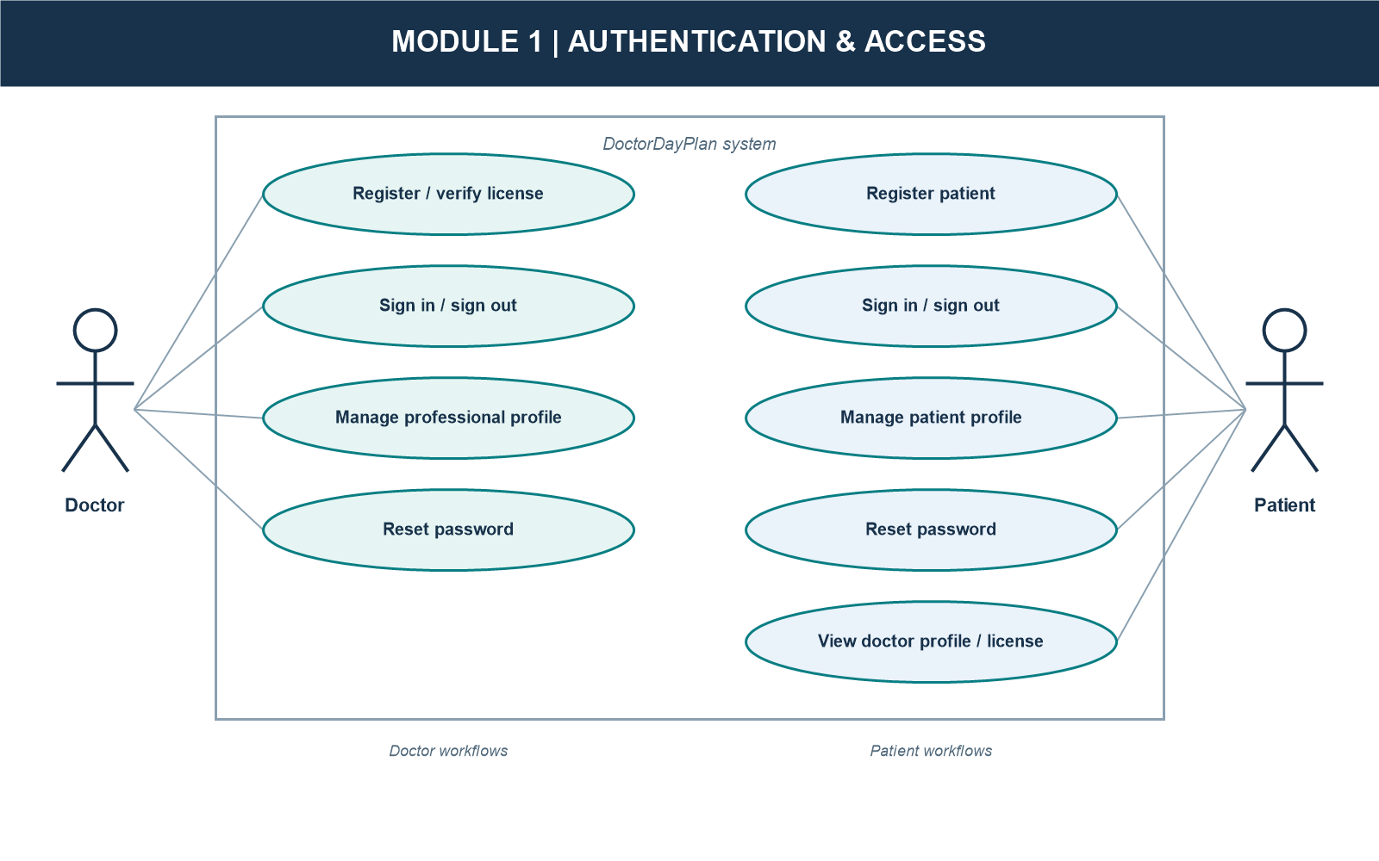

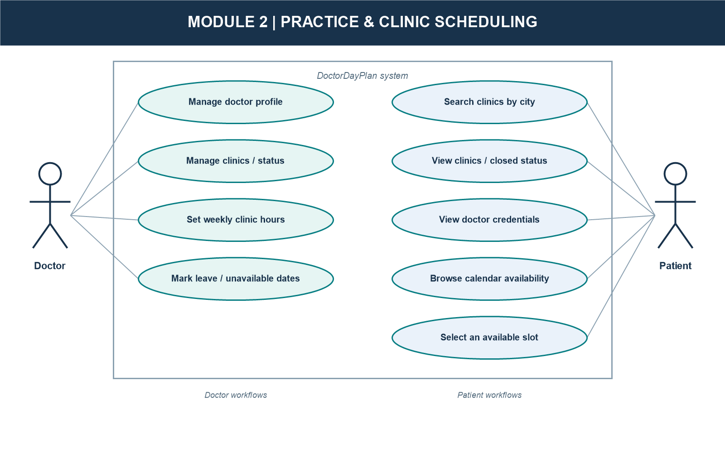

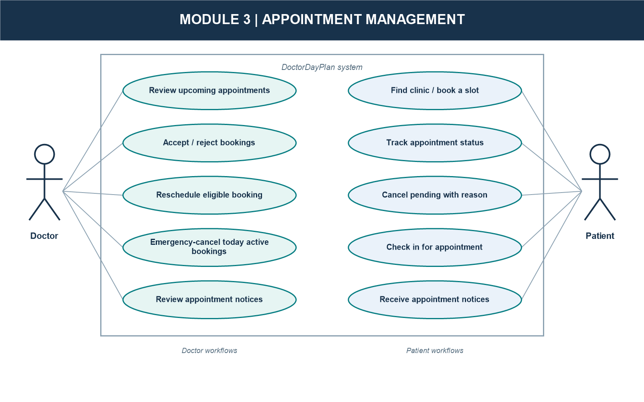

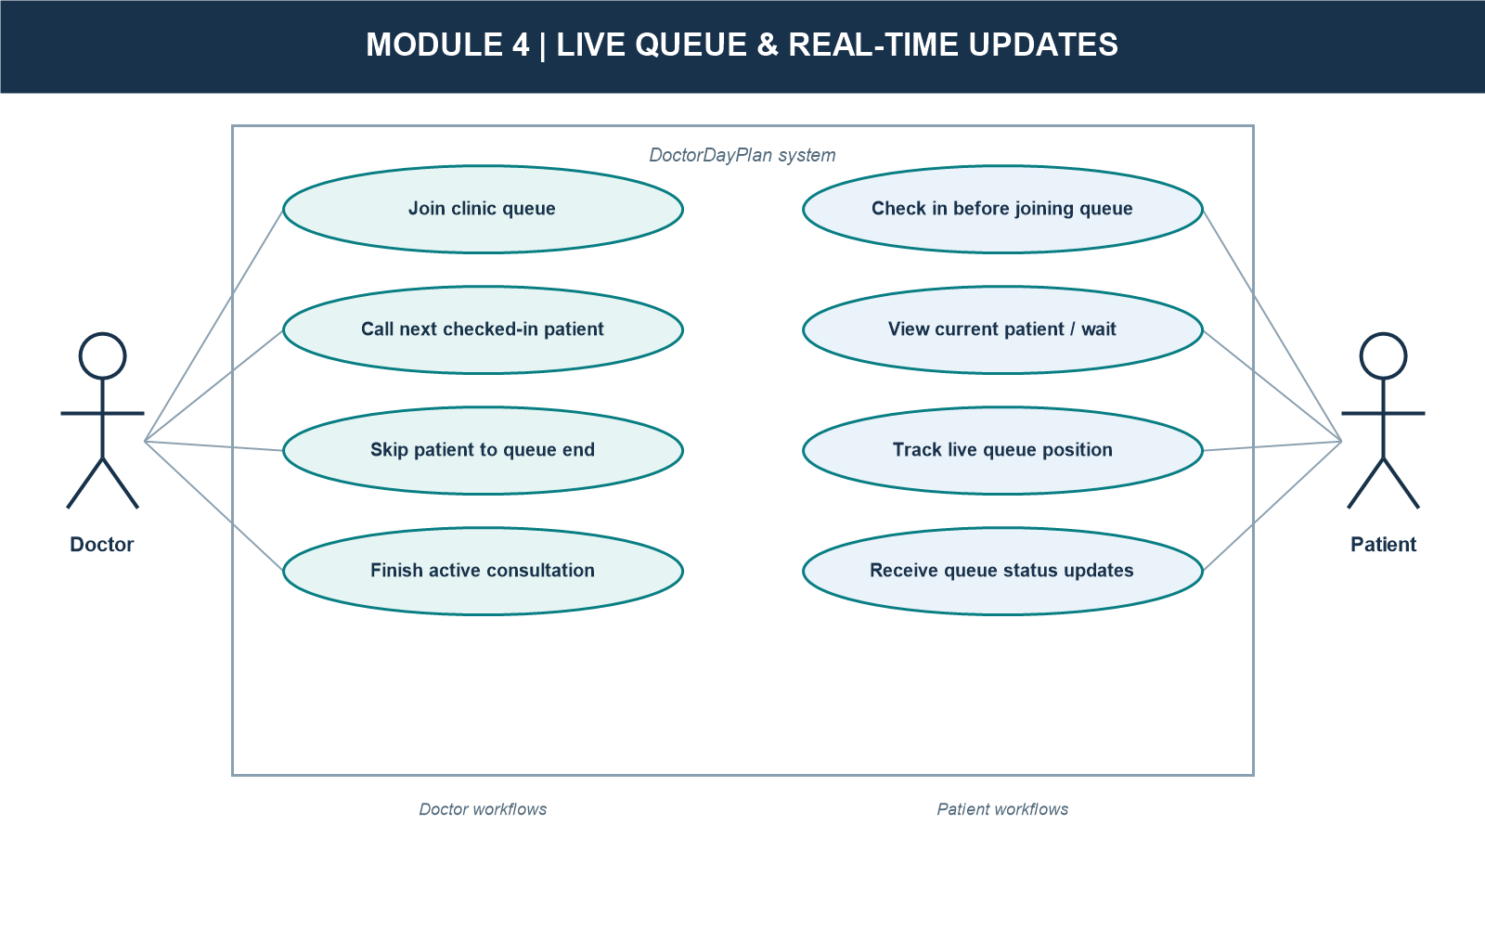

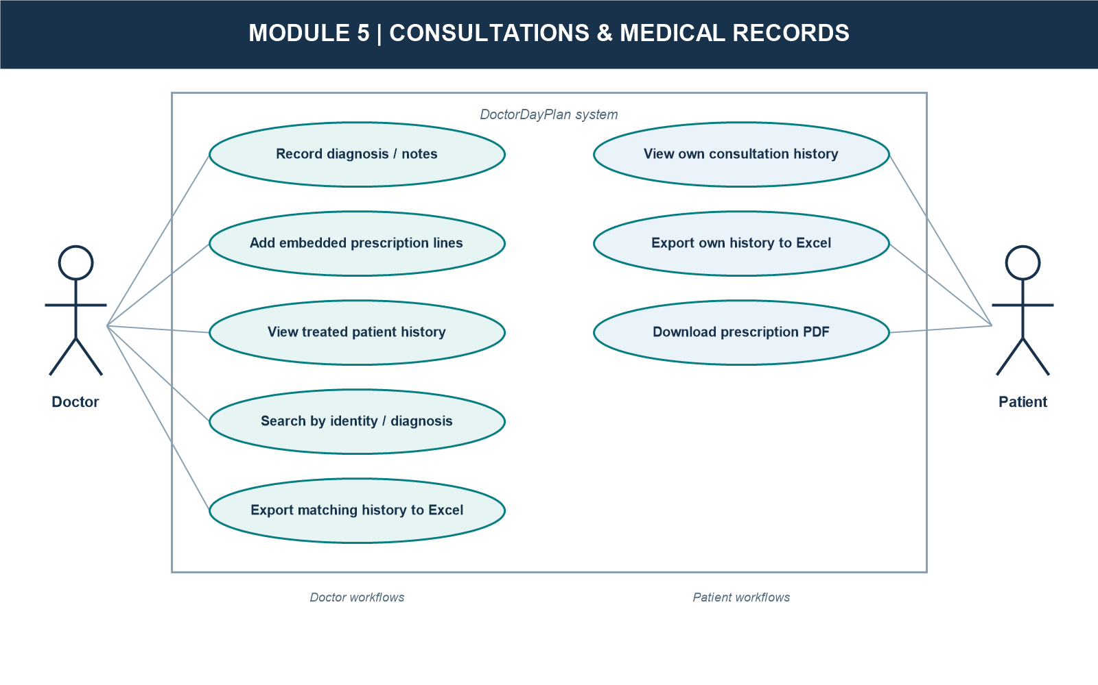

ER Diagram:
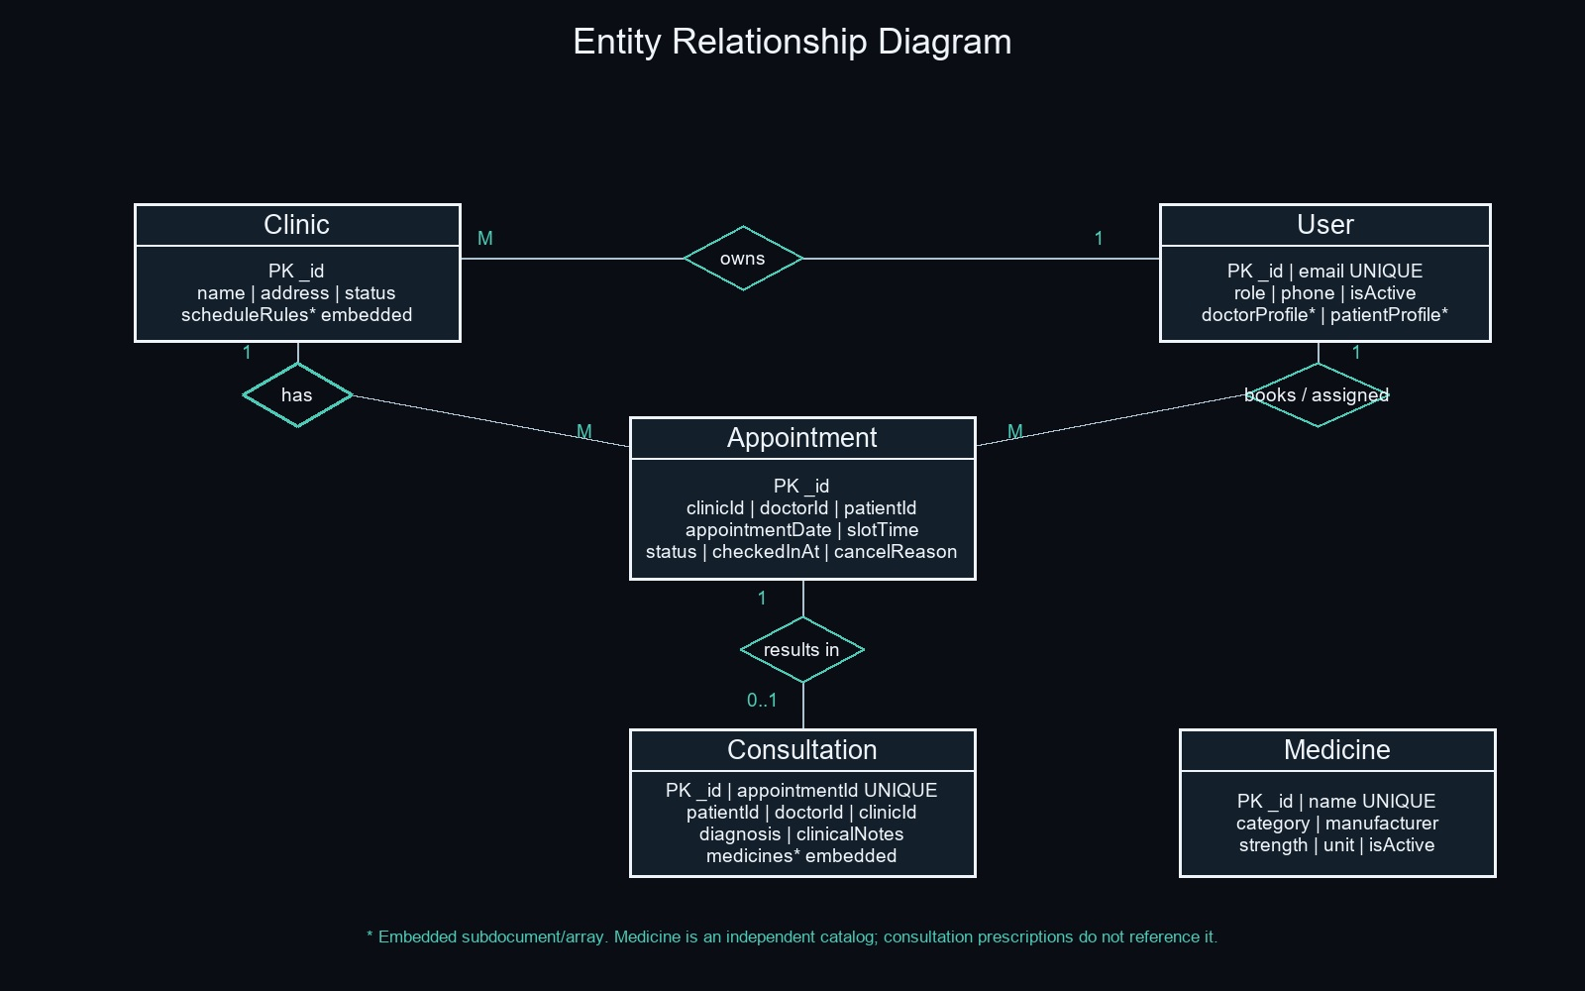

Data Dictionary
Collection 1: User
Purpose: Stores doctor and patient accounts, embedded role profiles, password hashes, account status, and private password-reset data.
Field | Type | Required | Default | Description
_id (PK) | ObjectId | Yes | Auto-generated | Primary document identifier.
email | String | Yes | None | Unique, lowercase, trimmed login email.
passwordHash | String | Yes | None | bcrypt hash; excluded from normal query results.
role | Enum String | Yes | None | doctor or patient.
phone | String | Patient: yes; doctor: no | None | Optional leading plus and 7-15 digits.
isActive | Boolean | No | true | Account activation state.
doctorProfile | Embedded Object | For doctors | Unset otherwise | Doctor profile; fields detailed below.
patientProfile | Embedded Object | For patients | Unset otherwise | Patient profile; fields detailed below.
passwordResetToken | String | No | None | SHA-256 hashed reset token; select:false.
passwordResetExpires | Date | No | None | Reset-token expiry; select:false; 15-minute lifetime.
createdAt | Date | Automatic | Current timestamp | Mongoose creation timestamp.
updatedAt | Date | Automatic | Current timestamp | Mongoose last-update timestamp.

doctorProfile (Embedded)
Field | Type | Description
name | String | Required, trimmed doctor name.
licenseNumber | String | Required; 2-5 letters, hyphen, 2-7 digits; sparse unique index.
specialization | String | Optional, trimmed medical specialization.
qualification | String | Optional, trimmed qualification.
experienceYears | Number | Optional; minimum 0.
bio | String | Optional, trimmed biography.
defaultSlotDurationMins | Number | Default 15; minimum 5.
avgConsultationMins | Number | Default 15; minimum 5.
unavailableDates | Array | Default []; entries contain required date and optional reason; embedded entry has no _id.

patientProfile (Embedded)
Field | Type | Description
name | String | Required, trimmed patient name.
dob | Date | Required date of birth.
gender | Enum String | Required; Male, Female, or Other.

Collection 2: Clinic
Purpose: Stores doctor-owned clinic locations, status, contact details, and weekly schedule rules.
Field | Type | Required | Default | Description
_id (PK) | ObjectId | Yes | Auto-generated | Primary document identifier.
doctorId | ObjectId ref User | Yes | None | Owning doctor; indexed.
name | String | Yes | None | Trimmed clinic name.
address | String | Yes | None | Trimmed clinic address.
contactPhone | String | No | None | Optional validated phone number.
status | Enum String | No | active | active or inactive.
scheduleRules | Array | No | [] | Weekly schedule; embedded rules detailed below.
createdAt | Date | Automatic | Current timestamp | Mongoose creation timestamp.
updatedAt | Date | Automatic | Current timestamp | Mongoose last-update timestamp.

scheduleRules (Embedded)
Field | Type | Description
dayOfWeek | String | Required; weekday name Monday through Sunday.
startTime | String | Required 24-hour HH:mm time.
endTime | String | Required 24-hour HH:mm time.

Collection 3: Appointment
Purpose: Stores appointment date/time, participants, status, check-in, and cancellation details.
Field | Type | Required | Default | Description
_id (PK) | ObjectId | Yes | Auto-generated | Primary document identifier.
clinicId | ObjectId ref Clinic | Yes | None | Clinic where the appointment is scheduled.
doctorId | ObjectId ref User | Yes | None | Doctor assigned to the appointment.
patientId | ObjectId ref User | Yes | None | Patient who booked the appointment.
appointmentDate | Date | Yes | None | Calendar date of the appointment.
slotTime | String | Yes | None | 24-hour HH:mm time, stored separately from appointmentDate.
status | Enum String | No | pending | pending, confirmed, inConsultation, rejected, cancelled, completed.
checkedInAt | Date | No | null | Check-in timestamp.
cancelReason | String | No | None | Optional trimmed cancellation reason.
createdAt | Date | Automatic | Current timestamp | Mongoose creation timestamp.
updatedAt | Date | Automatic | Current timestamp | Mongoose last-update timestamp.

Indexes and Uniqueness Constraints
Collection | Index Keys | Constraint / Purpose
User | email: 1 | Unique login email.
User | doctorProfile.licenseNumber: 1 | Unique sparse doctor license number.
Clinic | doctorId: 1 | Doctor clinic lookup.
Appointment | clinicId: 1, appointmentDate: 1, slotTime: 1 | Unique slot; prevents double booking.
Appointment | doctorId: 1, appointmentDate: 1 | Doctor appointment lookup.
Appointment | patientId: 1 | Patient appointment lookup.
Consultation | appointmentId: 1 | Unique; at most one consultation per appointment.
Consultation | patientId: 1, createdAt: -1 | Patient history ordering.
Consultation | doctorId: 1, createdAt: -1 | Doctor consultation lookup.
Medicine | name: 1 | Unique medicine catalog name.

Collection 4: Consultation
Purpose: Stores one consultation per appointment, including diagnosis, clinical notes, and embedded prescription lines.
Field | Type | Required | Default | Description
_id (PK) | ObjectId | Yes | Auto-generated | Primary document identifier.
appointmentId | ObjectId ref Appointment | Yes | None | Unique; consultation belongs to one appointment.
patientId | ObjectId ref User | Yes | None | Patient treated.
doctorId | ObjectId ref User | Yes | None | Doctor conducting the consultation.
clinicId | ObjectId ref Clinic | Yes | None | Clinic where consultation occurred.
diagnosis | String | Yes | None | Required trimmed diagnosis.
clinicalNotes | String | No | None | Optional trimmed clinical notes.
medicines | Array of embedded objects | No | [] | Lines contain name, dosage, durationDays, and optional instructions; embedded entries have no _id.
createdAt | Date | Automatic | Current timestamp | Mongoose creation timestamp.
updatedAt | Date | Automatic | Current timestamp | Mongoose last-update timestamp.

Collection 5: Medicine
Purpose: Stores the medicine catalogue. Consultation prescriptions are embedded line items with their own medicine name and dosage details.
Field | Type | Required | Default | Description
_id (PK) | ObjectId | Yes | Auto-generated | Primary document identifier.
name | String | Yes | None | Trimmed, unique medicine name.
category | Enum String | Yes | None | Tablet, Capsule, Syrup, Injection, Ointment, Drops, Inhaler, or Other.
manufacturer | String | No | None | Optional trimmed manufacturer.
strength | String | No | None | Optional trimmed strength.
unit | Enum String | No | None | Optional: mg, ml, g, mcg, or IU.
isActive | Boolean | No | true | Catalogue active state.
createdAt | Date | Automatic | Current timestamp | Mongoose creation timestamp.
updatedAt | Date | Automatic | Current timestamp | Mongoose last-update timestamp.

DoctorDayPlan v1.1 - Updated Requirements
  - Implementation-aligned addendum | 4 October 2026
Purpose and precedence.
This addendum updates the original DoctorDayPlan v1.0 requirements using the implemented application and current project specifications. The original diagrams, tables, and baseline text are preserved. Where a v1.0 statement conflicts with this addendum, this addendum is authoritative for the implemented v1.1 system.

1. Updated Product Scope
DoctorDayPlan is a doctor-centric practice management system for independent doctors and their patients. It supports authenticated doctor and patient workspaces, clinic scheduling, appointment lifecycle management, live checked-in queues, consultation records, prescription PDFs, patient search, notifications, and Excel exports.

Doctor capabilities
- Register, sign in, maintain a professional profile, and provide a required unique medical license number.
- Create and manage multiple clinics, weekly schedules, clinic status, and unavailable dates.
- Review, accept, reject, and reschedule appointments; manage checked-in patients in a live queue.
- Record diagnoses, clinical notes, and prescribed medicine details; review patient histories and download prescriptions.
- Search patients by name, email, phone, or diagnosis, and export histories for all matching patients to Excel.
- Send an emergency cancellation notice to patients with active appointments scheduled for that day.

Patient capabilities
- Register, sign in, maintain a patient profile, browse doctor and clinic details, and view public doctor credentials.
- Find clinics by city, view availability, and book an available appointment slot.
- Track booking status, check in, view live queue position, and cancel an eligible pending appointment with a reason.
- View consultation history, prescribed medicines, and download prescription PDFs.
- Receive appointment booking, status, reschedule, cancellation, and emergency notifications when delivery is configured.

3. Implemented v1.1 Requirements

Authentication and profile security
- Doctor registration and profile updates require a unique license number matching 2-5 letters, a hyphen, and 2-7 digits (5-10 characters total).
- Forgot-password responses are generic; reset tokens are SHA-256 hashed, expire after 15 minutes, and can be used once. Passwords require at least 8 characters with a letter and a number.
- Protected API operations enforce JWT identity and doctor/patient role authorization.

Clinic scheduling and booking
- Clinic schedules use weekday names and 24-hour HH:mm times. Patient booking is city-first; inactive clinics remain visible but disabled and are rejected by the server.
- Booking validates clinic ownership, date/time, and clinic status. A compound unique slot index prevents duplicate bookings; cancelled and rejected appointments release their slots.
- Patients select dates on a monthly availability calendar; booked slots remain visible but disabled.

Appointment lifecycle and notifications
- Doctors may confirm or reject an appointment. Patients may cancel only a pending appointment and must provide a reason.
- Doctors may reschedule pending or confirmed appointments to an unoccupied future slot. A rescheduled appointment returns to pending confirmation.
- Appointment lists use server pagination. Export requests can use all=true, capped at 5,000 records.

Consultations, search, and export
- A consultation is limited to one per appointment. Patient, doctor, and clinic relationships are derived from the appointment; the appointment is marked completed after the consultation is saved.
- Consultation creation supports standalone MongoDB deployments through the unique appointment constraint and compensating deletion if appointment completion fails. This is not a multi-document ACID transaction; deployments requiring atomic cross-document writes must use a replica set.
- Doctor patient search matches name, email, phone, and the doctor's consultation diagnosis text. Search results identify matched diagnoses.
- SheetJS exports include histories for all matching patients, including matches beyond the displayed search page; rows include patient identity and consultation details.
- PDFKit streams prescription PDFs directly to the response. The frontend checks PDF content type before saving.

Live queue
- Patient check-in adds the appointment to its clinic queue. Socket.IO updates include the current patient, waiting queue, and estimated wait time.
- Doctors can call the next patient, move a skipped patient to the end of the waiting queue, and finish the current consultation. Call and finish transitions update appointment status.
- Queue state is held in memory and rehydrated from checked-in confirmed/inConsultation appointments when a clinic room is joined. The client joins after socket connection and rejoins after reconnect.

Notifications and user feedback
- Notifications cover booking, doctor accept/reject, patient cancellation (including doctor notice with reason), doctor rescheduling, and doctor emergency cancellation.
- Email uses configured SMTP/Nodemailer; SMS uses configured Twilio credentials. Without providers, demo mode records messages to the backend console and notification outbox. NOTIFICATIONS_ENABLED=false disables delivery and demo recording.
- Long-running booking, appointment decision, cancellation, reschedule, and emergency actions show pending button states and prevent duplicate submissions.

5. API Pagination and Export Contract
Paginated list APIs return { data, pagination: { total, page, limit, totalPages } }. The default page size is 10, the maximum requested page size is 100, and all=true returns at most 5,000 records. This contract applies to upcoming appointments, patient appointment history, patient consultation history, and doctor patient search. Patient-search history export accepts the same query and exports consultation rows for every matching patient within the cap.

6. Technology and Operational Requirements
- Frontend: React, React Router, Tailwind CSS v4, Axios, socket.io-client, and SheetJS xlsx.
- Backend: Node.js/CommonJS, Express, Mongoose, MongoDB, JWT, bcrypt, Socket.IO, PDFKit, Nodemailer, and Twilio REST API integration.
- Configuration and secrets are provided through environment variables. Vite client variables use the VITE_ prefix.
- Validation is enforced on the server and mirrored in form controls. Form fields have labels and useful hints; paginated history keeps existing rows visible during page requests.
- Verification gates: backend Jest tests (`npm.cmd test` from backend); frontend production build and lint (`npm.cmd run build` and `npm.cmd run lint` from frontend).

